We have one VM missing "Insert VM Driver" icon, can’t install VM driver

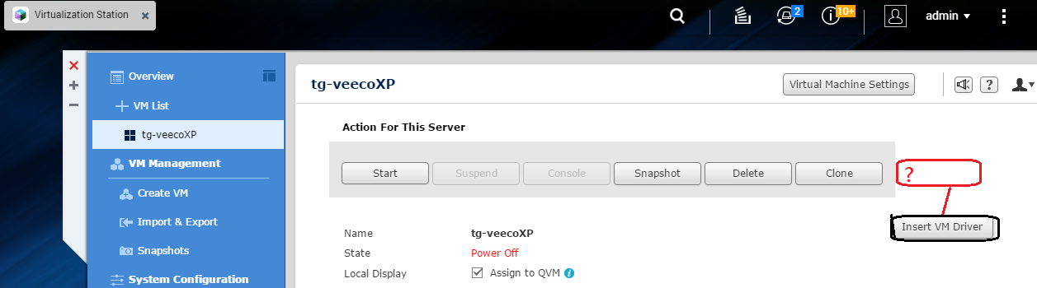

The correct should be like below figure.

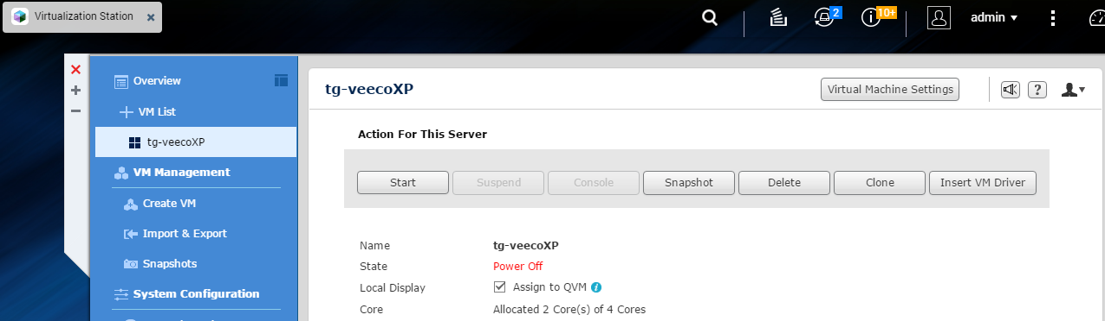

Please check whether has any the CD/DVD ROM device in Virtual Machine Settings.

If No Device, the "Insert VM Driver" icon will not show on.

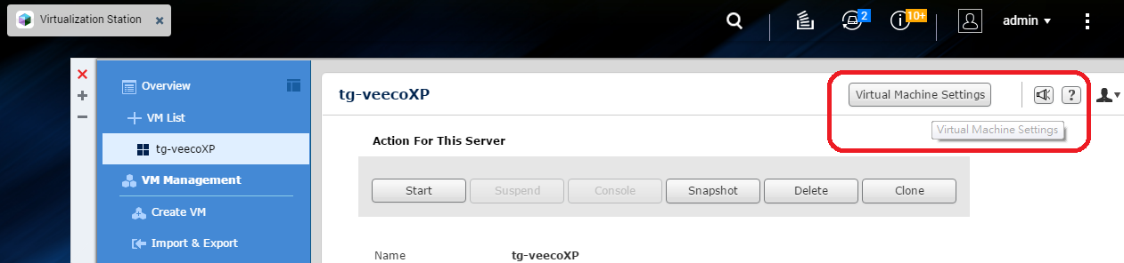

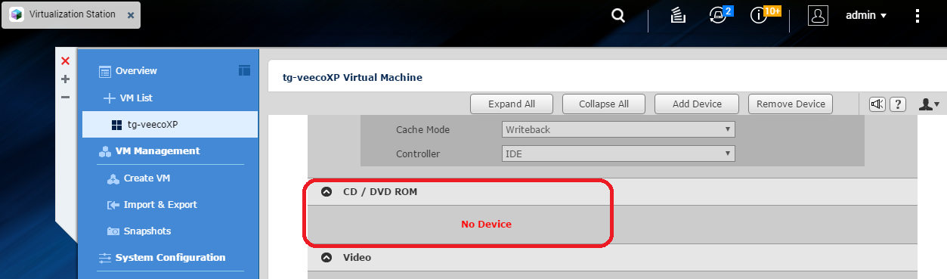

Please Add CD/DVD ROM Device, and then "Insert VM Driver" icon will show on

